**Stepper Motor Controller Rev. 0**

**Testing**

# Test Setup

## Hardware

A fully populated Stepper Motor Controller Rev. 0 with a 16x2 I²C LCD-display was tested with three different stepper motors:

1. 17HS13-0404S (NEMA17, 12V, 0.4A/phase, 1.8° steps)
2. 17HS8-1004S (NEMA17, 12V, 1A/phase, 1.8° steps)
3. 17HS13-0404S-PG5 ((NEMA17, 12V, 0.4A/phase, 1.8° steps, 1:5.182 gear)

The voltage supply is a Goobay SE120P3000EU (12V/3A output on a 2.5mm/5.5mm barrel connector).

A USB-RS-232-Adapter was used for testing then RS-232 interface.

The software “stepper_framework.ino” was uploaded to the Pro Micro via the USB interface.

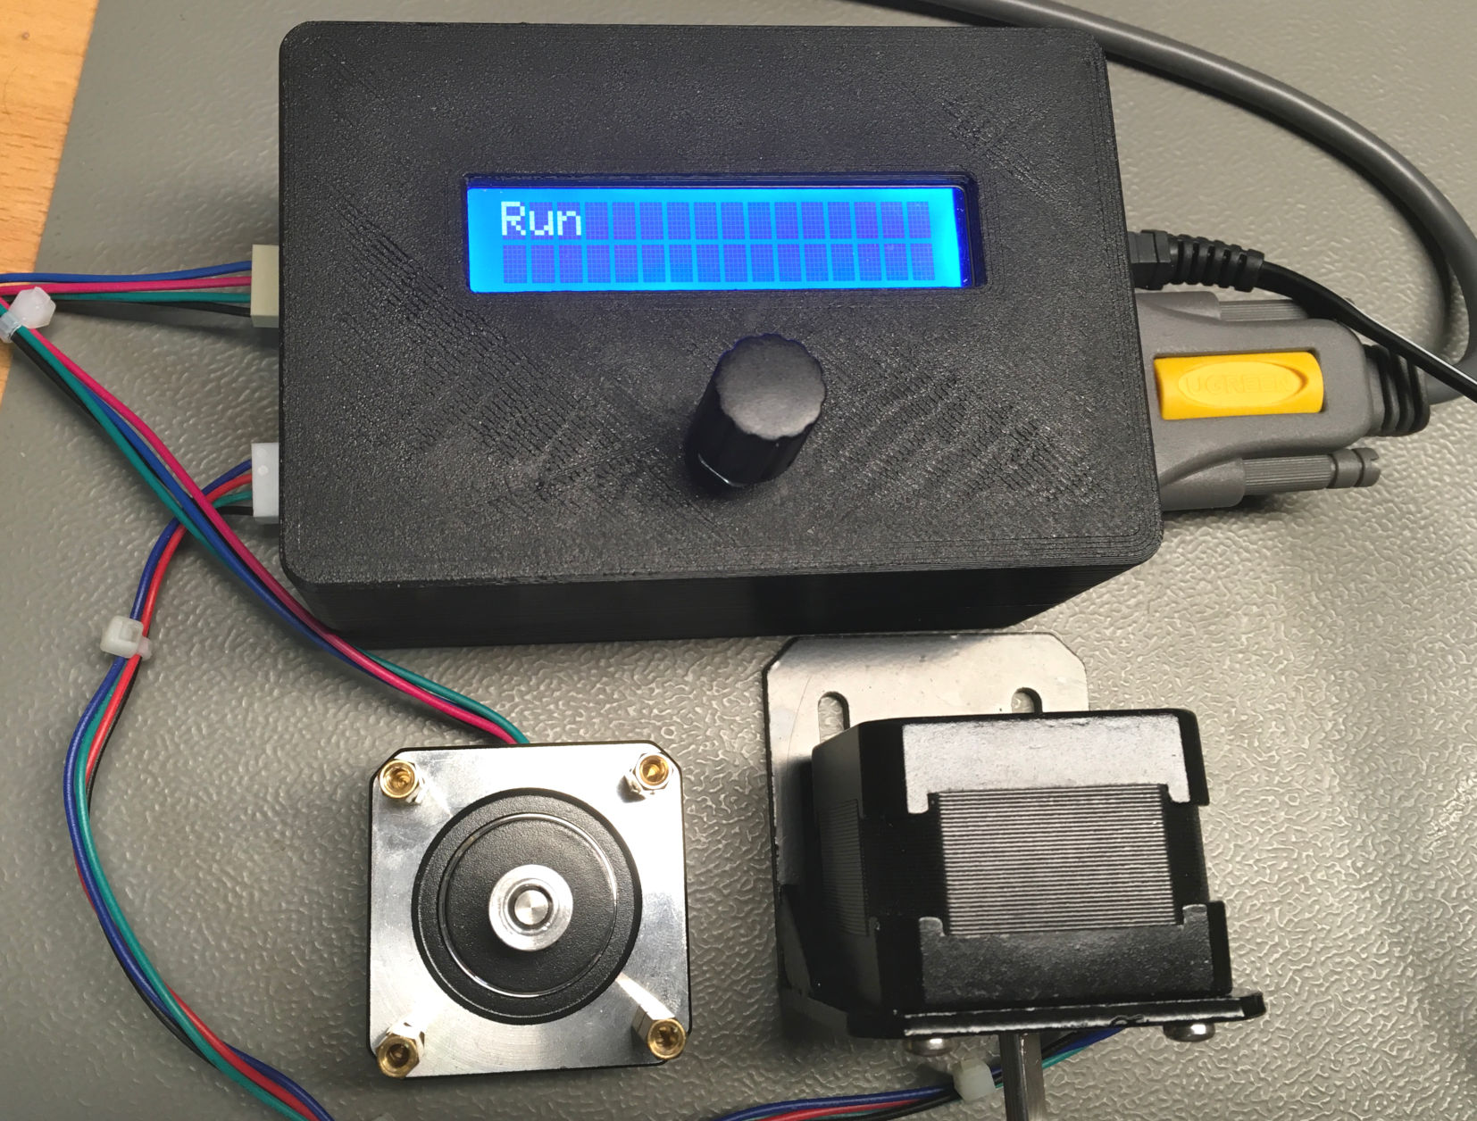

Figure : Test Setup

## YAT – Terminal Program

To communicate with the Stepper Motor Controller via RS-232, a terminal program is required. The serial monitor of the Arduino IDE only works on the COM-Port, that is selected for sending the sketch. A recommended one is YAT (“Yet, Another Terminal”).

<https://sourceforge.net/projects/y-a-terminal/files/latest/download>

# Test Execution

## Software upload

The software “stepper_framework.ino” was uploaded with the Arduino IDE successfully.

## Power

After connection the +12V-PSU the Stepper Controller powered up properly. The +5V from the linear voltage regulator were measured as +5.03V at the stepper driver A4988. The +12V (12.3V without load) from the PSU were measured as +12.14V at the stepper driver, too.

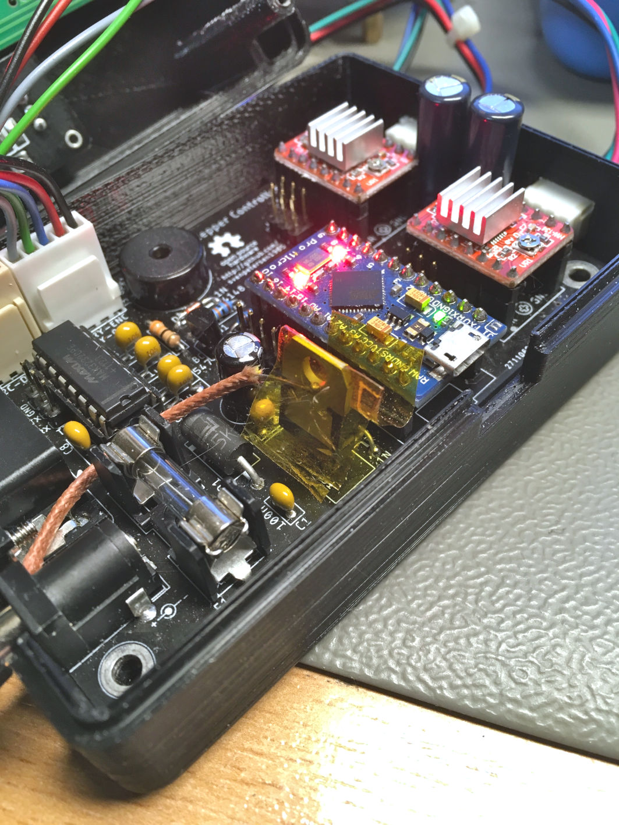

Figure 2: Thermal measurement on linear regulator IC1

The supply current was measured while in the “STOP” state (no current through the stepper motor windings). It is about 93.5mA. When in “RUN” state, a supply current of 850mA was observed. This does not change much while a stepper motor is running and mostly depends on the stepper motors used and the current adjustment of the stepper driver.

When powered from +12V, the linear regulator settles at about 57°C, which is non critical.

|  |  |
| --- | --- |
| Time | Temperature |
| Start | 21.6°C |
| Start + 75 minutes | 56.9°C |

The thermal resistance junction-case (RthJC) is 5K/W according to the data sheet. The dissipated power is

$$P_{D}=\left(V_{in}-V_{out}\right)∙I=\left(12V-5V\right)∙93.5mA=0.655W$$

Hence, the estimated junction temperature is

$$ϑ_{Junction }= ϑ_{Case}+R_{thJC}∙P_{D}=56.9°C+5\frac{°C}{W}∙0.655W≅60.2°C$$

This is far below the absolute maximum rating of 150°C.

The measurements were executed with a EEVBlog 121GW multimeter. The thermo couple was fixed to the backside of the 78S05/IC1 (refer to Figure 2). The case was closed for the thermal measurement.

## Piezo Buzzer

The piezo buzzer beeps after switching on the power. It can be heard well even while the case is closed.

## LCD Display

The LCD display initialized properly and the text appeared as desired. The contrast had to be adjusted slightly (potentiometer on the LDC-display).

## Rotary Encoder

The push button and both directions were detected properly with the installed software.

## Stepper Driver

Both stepper motors executed the full steps set with the rotary encoder. Both directions work. Further, the half, quarter, 1/8 and 1/16 micro-steps were configured with the jumpers. The micro-steps were not carried out evenly, so an adjustment of the stepper current (potentiometer on the A4988 modules) was required. After setting the current limit properly, the steps were carried out evenly. The setting was adjusted “by ear”.

All three stepper motors were tested.

## RS-232 Interface

The RS-232 serial interface was tested with YAT (set to 9600baud, 8N1).

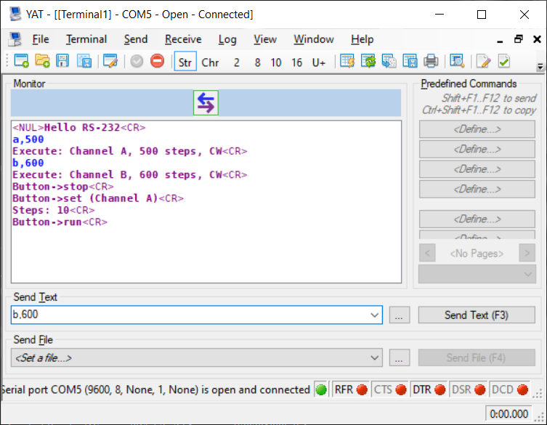

Figure 3: Terminal Program YAT communicating with the Stepper Motor Controller

Both, the send and receive direction work properly. The messages from the stepper controller were displayed correctly in YAT and the sent command were recognized by the stepper controller and executed.

# Conclusion

**The Stepper Motor Controller is working properly. The DC/DC-converter has not been tested.**